MEDIA KIT

AUTHOR KENNETH EADE
Quick Bites

“How do I write? Like Hemingway. I just ‘sit at the typewriter and bleed.’ Except, in my case, it’s a PC.”
“Justice is rarely dispensed within the four walls of the courtroom.”
“Fair is irrelevant. The law has nothing to do with justice.”
“Some of the most likeable people are truly capable of the most heinous things.”
“Violence has a way of overpowering even the strongest of wills.”
“The Internet is great. It connects you to long lost old friends, and many new ones; none of whom you will ever see.”
“The only time you can really be sure you’re not being lied to is when you’re talking to yourself.”
“The jury system is somewhat of an anomaly, like everything else in the law.”
“Politicians are pathological liars. It’s easier to commit a fraud when the actor believes his lie to a point of conviction.”
“From anonymous bullying to murder-for-hire, the Internet has something for everyone’s sick tastes.”

Critics

“Eade is not only a brilliant writer, he calls attention to the atrocities that surround us, hiding in our own closets. Once you read an Eade thriller, you can only be hungry for more.” – Grady Harp, Literary Aficionado, Amazon Hall of Fame.
“Fans of Grisham will find equal talent in Eade’s ability to captivate and hold readers with the unexpected, both in character development and non-stop action. In a world where plot and outcome are often predictable from the start, this will prove more than satisfying for readers already well versed in the legal thriller format.” – Midwest Book Review.

Author Kenneth Eade, best known for his legal and political thrillers, practiced law for 30 years before publishing his first novel, "An Involuntary Spy." Eade, an up and coming author in the legal thriller and courtroom drama genre, has been described by critics as "Brilliant when it comes to creating complicated, intriguing stories that end in mind-blowing surprises, who have said that his novels will remind readers of John Grisham, proving that Kenneth Eade deserves to be on the same lists with the world's greatest thriller authors."
Says Eade of the comparisons, "Readers compare my style to John Grisham’s. Although there are some similarities, because John also likes to write about current topics and we are both lawyers, all my novels are centered around important issues, not fantasy.”
Eade has written seven novels, which are currently being translated into ten different languages. He is known to keep in touch with his readers, offering free books and discounts to all those who sign up at his web site, www.kennetheade.com.
Email: info@kennetheade.com
Facebook: https://www.facebook.com/KennethGEadeBestsellingauthor
Twitter: https://twitter.com/KennethEade1

http://www.huffingtonpost.com/getrude-matshe/political-and-legal-thril_b_6812954.html
http://www.digitaljournal.com/entertainment/dark-world-of-gmo-in-kenneth-eade-s-thriller-an-involuntary-spy/article/364570
http://www.lifehack.org/303444/3-inspiring-writers-who-will-make-you-laugh-become-smarter-and-more-emotionally-intelligent

A PATRIOT’S ACT
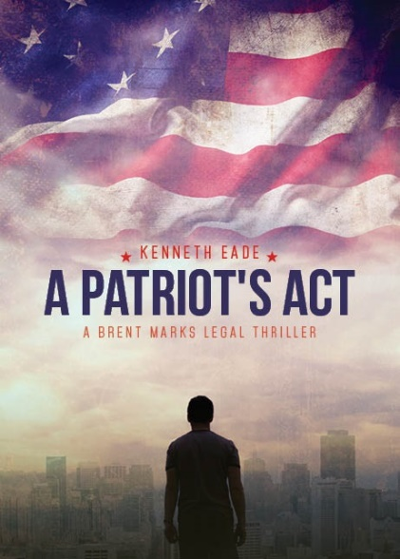
Death, law and in that order in Guantanamo Bay
In “Patriot’s Act,” when a Santa Barbara accountant, Ahmed Khury, is subjected to torture after aiding his brother, Brent Mark comes into the picture and fights the Goliath U.S. government with its own constitution. The drama outside the courtroom explodes as murder, corruption, and a cover-up, enters the scene that makes everybody, including Brent, unsafe.
Being the first installment in a series of legal thrillers, “Patriot’s Act” exudes the value of profound patriotism weaved into legal dialogue and resolute practicality.
When asked of the inspiration behind his novel Eade shares, “All of my fictional novels seem to be real because they surround a certain social issue that I feel strongly about. In this book, I took on the USA Patriot Act, which I feel has abrogated our rights guaranteed by the Fourth Amendment, as well as the military prison and tribunal system at Guantanamo Bay, which has denied inmates the right to counsel, to cross-examine and confront witnesses, and the right to be free from cruel and unusual punishment.”
Kenneth’s novel is not only beguiling but groundbreaking as well. Recent reviews made of the sensational write-up have labeled the book to be a masterpiece with unexpected twists and a sensational page-turner.
Published by Tate Publishing and Enterprises, the book is available through bookstores nationwide, from the publisher at www.tatepublishing.com/bookstore, or by visiting barnesandnoble.com or amazon.com.
Joseph Hickman said, Former Guantanamo Guard, Adjunct Professor at Seton Hall Law School and Author of “Murder at Camp Delta” said, "Kenneth Eade has written a masterpiece! Not only is A Patriot's Act a gripping novel where the characters in the book come alive, Eade also gives a real life glimpse into Guantanamo Bay, and the conditions inside the detainee camps. Throughout the book you see and feel through his characters what the detainees at Guantanamo go through, and the never ending hurdles the attorneys have to overcome to represent them. This book is required reading for anyone who cares about liberty and justice."
In’D Tale Magazine said, “An edge-of-your-seat thriller that could easily be transformed into a dramatic film. Simply riveting, start to finish!”
SPR Review said, "Eade, a lawyer by profession, weaves legal dialogue, corruption and international action to create a pacey read with echoes of Grisham, Baldacci and Clancy nipping at his writing heels. Law issues as well as forensics and police procedures are clearly explained with such authority as to add gritty realism in and out of the courthouse, but it's within the court drama that Eade really packs some punch. With some success with the first book of the series, Predatory Kill, this second saga looks sure to satisfy his growing base of readers.
Midwest Book Review said, "It's all about delicate balance of power and experience - something gone awry in A Patriot's Act, and something explored through intimate descriptions. As Eade deftly juxtaposes the lives of two very different Americans experiencing two very different circumstances, he delves into the politics and processes of prisoners and military men alike, exposing the wounds of their experience and psyches and the points at which man's inhumanity stems from a worldview that dehumanizes and rips apart systems and people."
In "A Patriot's Act," lawyer Brent Marks from "Predatory Kill" is back in action in the second novel of the popular legal thriller series by Kenneth Eade. When a naturalized American citizen turns up missing in Iraq, Brent Marks fights the Goliath U.S. government with its own Constitution.
Santa Barbara accountant Ahmed Khury responds to the plea of help of his brother, Sabeen, a suspected money launderer in Iraq. Before Ahmed realizes what has happened to him, he is in Guantanamo Bay detention camp (think Camp X-Ray), being subjected to torture to extract information that he doesn't have. When murder, corruption and cover-up enters the picture, nobody, including Brent, is safe.
"This novel is a story of corruption and an imbalance of power. The indefinite detention and torture of those suspected of terrorism in Guantanamo Bay and the USA Patriot Act are two of the most shameful events of our time," said Kenneth Eade, the author.
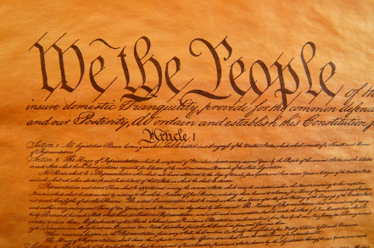 In 2004, Brandon Mayfield, an American lawyer was arrested on the basis of evidence concocted by the FBI and CIA, based on his fingerprints, which showed a possible match to the Madrid train bombings. He was arrested at his home in Oregon, held, without charge, for two weeks, and his home was searched without a warrant, under authority of the Patriot Act, which has virtually thrown the Fourth Amendment out the window. In 2006, two private American citizens working for private security contractors in Iraq, were arrested, tortured and held indefinitely in a U.S. military prison in Iraq; one for six weeks and one for three months.

Since the U.S. government takes the position that anyone who is arrested on suspicion of terrorism outside the United States, and particularly in an area of conflict, is not entitled to any due process, I thought it would be interesting to follow the case of a naturalized American citizen who is arrested while visiting his brother in Iraq, thrown into Guantanamo Bay Detention Camp and subjected to torture. “I wrote it as a prequel to Predatory Kill, because it occurred in a time prior to PK and my fans told me that they liked the interaction between Brent and his investigator, Rick Penn, so I brought Rick back for this novel.”

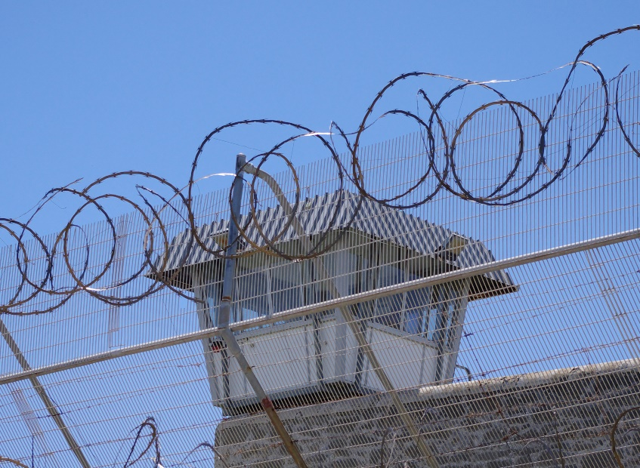Amnesty international has called the Guantanamo Bay Detention Camp the “gulag of our time.” Since President Obama’s order to close the camp within one year on January 23, 2009, it has remained open because the president decided to amass political capital to use for his domestic agenda instead. On January 7, 2011, Obama signed the 2011 Defense Authorization Bill, which placed restrictions on transferring prisoners to the United States. As of May 2014, there were 149 detainees being held, at a cost to the government of roughly $1 million per detainee. Some of them have been held, without trial and without charge, since 2003. 46 of them have been declared by the government to be too dangerous to release, but they cannot be tried for any crime because there is insufficient evidence to try them. Approximately half of the detainees held today have been cleared for release, but may never regain their freedom. Many of their native countries have refused to repatriate them, and, because of the new legislation, they cannot be transferred to prisons in the United States.
Courts have upheld detentions at Guantanamo under the Authorization for Use of Military Force passed by Congress three days after the September 11th attacks. The reasoning behind this is to keep enemy soldiers from returning to the battlefield until the conflict is over. However, the current conflicts in Iraq and Afghanistan show no sign of being over, especially with the rise in power of ISIS; which is a direct result of U.S. intervention and destruction of infrastructure. Moreover, because of the enormous problem of policing, the incredible expense of rebuilding, and the $700 billion U.S. defense budget, it is foreseeable that the “military conflict” could go on for decades, to the delight of military contractors like Halliburton, Lockheed and General Dynamics. War is good for business.
When the United States military arrested the detainees and threw them into Guantanamo Bay Detention Camp indefinitely, they denied them the right to counsel guaranteed by the Sixth Amendment. They also denied them the right to a speedy trial, to confront the witnesses against them, to a trial by jury, and the right to be informed of what they were charged with. They denied them the right to a trial by jury, guaranteed by the Fifth Amendment, their right to due process of the law by holding them indefinitely with no charge, and their privilege against self-incrimination.
Finally, and most importantly, by beating them, torturing them and treating them as less than human, using sensory deprivation and sensory overload as interrogation enhancement techniques, and force feeding and torturing them, the Government denied them the Eighth Amendment guarantee to be free from cruel and unusual punishment. Not only were detainees denied the constitutionally guaranteed rights to which any person imprisoned in the United States would be entitled, no matter what heinous crime of which they stand accused, they were also denied the rights that any enemy soldier captured fighting against the United States would get pursuant to the Geneva Conventions of 1949. Article 3 of the Geneva Conventions prohibits detention practices that are “cruel, degrading, or humiliating.”
President Bush and the military complex under his command continued to deny all basic rights to detainees, including the constitutional guarantee of habeas corpus, and the Congress went along with it, in passing a series of Acts of Congress attempting to limit this constitutional guarantee.
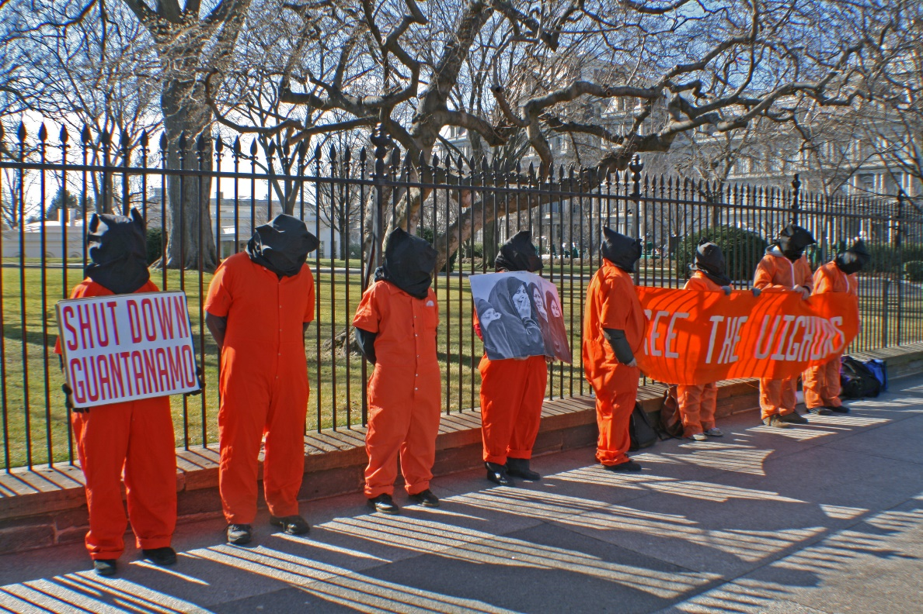
In 2004, the United States Supreme Court held, in Rasul v. Bush, that the habeas corpus jurisdiction of United States federal courts extended to Guantanamo Bay. In 2004, the Court also held, in Hamdi v. Rumsfeld, that due process mandated that an alleged enemy combatant held on U.S. soil be entitled to a due process challenge of his enemy combatant status.
In June 2006 the Supreme Court, in Hamdan v. Rumsfeld threw out section 1005a of the Detainee Treatment Act denying the right of an alien detainee to habeas corpus, and ruled that the structure and procedures of the military commissions established to try detainees violated both the Uniform Code of Military Justice and Common Article 3 of the Geneva Conventions. Congress passed and Bush signed into law the Military Commissions Act in October 2006, overriding the Supreme Court’s decision.
In 2008, the Supreme Court threw out the Act’s prohibition of the federal courts’ jurisdiction to hear detainees’ habeas corpus petitions as an unconstitutional suspension of habeas corpus in Boumedine v. Bush.
District Court Judge Aiken threw out two sections of the Patriot Act that modified the Foreign Intelligence Surveillance Act in Mayfield v. United States, but her decision was rendered moot on appeal when the Ninth Circuit Court of Appeal decided that Mayfield could not pursue his declaratory relief claim after he had settled with the government.
The “War on Terror” is still on, and is still being used as an excuse to broaden or extend the broad brush of governmental power. The USA Patriot Act, which was designed to be temporary, has been reauthorized in 2005 and 2006. On February 27, 2010, President Obama signed into law legislation reauthorizing three controversial sections of the Act relating to roving wiretaps, lone wolf surveillance and seizure of property and records. On May 26, 2011, he signed into law the Patriot Sunsets Extension Act to extend key provisions of the Act.
What we are seeing now is continuation of the abuse of power which was instituted by an over-zealous president and that abuse of power must be stopped. It is turning the United States of America, once a beacon for liberty and freedom, and an example for every other democracy to follow, into an aggressive country that does not respect its own laws and does not play by its own principles. This is unacceptable, and we, as citizens of this country, need to send a clear message to our government that the United States is a good and humane nation, which does not torture prisoners of war. We are a nation of laws, a nation who respects our fellow humans and the rights of our own citizens, as well as the rights of citizens of other countries. We need to start acting like one.
What’s wrong with the Patriot Act? Plenty-it is the most pervasive joint attack by the Executive and Legislative branches of our government on the United States Constitution in history. The Patriot Act expanded the executive’s power to practical omnipotence, allowing the FBI and other government enforcement agencies to use “enhanced surveillance procedures,” which included roving wiretaps, which follow the suspect and encompass any communication technology used at any time, “sneak and peek” searches, for which the search can be conducted before the suspect is informed of the search warrant, and the production of books, records papers, documents and other items to be ordered not by a court of law, but by the FBI, the CIA or the Department of Defense in a “national security letter.” The Act also authorizes the forfeiture of assets of those suspected of money laundering, detention of up to two weeks of suspected terrorists who are United States citizens, and indefinite renewable detention of aliens from 90 days to six months. Thanks in part to a filibuster by Senator Rand Paul, the Patriot Act was allowed to sunset this year, only to be replaced by the USA Freedom Act, which reinstated most of the unconstitutional provisions with different requirements.

http://apatriotsact.com
Contact: michelle@keymgc.com
Michelle Whitman
Key Marketing Group
(405) 458-5642
Press release: http://amtrak.einnews.com/pr_news/280925346/simi-valley-author-lawyer-crafts-sensationally-moving-political-thriller

PREDATORY KILL

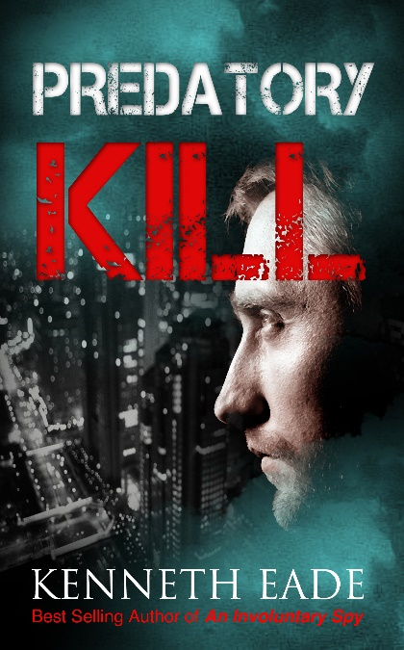

Can “Too Big to Fail” get away with murder?

Brent Marks had paid his dues as a lawyer, having taken his share of divorces and drunk driving cases over his 20 year career, but had finally reached a place in his life where he could take on cases of social importance. What he least expected was for April Marsh's predatory lending case against the big banks for wrongful foreclosure on her parent's home to turn into a murder investigation. April’s parents were brutally attacked in their Santa Barbara home; her mother murdered and the only witness to the crime is her father, who survived the attack but is completely incapacitated. The police have no leads, but April believes the predatory lender is behind it. Are banks really that above the law?
InD’Tale Magazine said, “This entertaining novel takes murder, corruption, and predatory practices, and ties them all together in courtroom drama, making it a riveting must read!”
Midwest Book review said, “Fans of Grisham will find equal talent here in Eade's ability to captivate and hold readers with the unexpected, both in character development in nonstop action which lays the foundation for a story that's anything but predictable. The realistic dialogue is - well - simply killer; while action points in one direction, then often takes a 360-degree turn. In a world where plot and outcome are often predictable from the start, this will prove more than satisfying to readers already well versed in the legal thriller format."

HOA WIRE

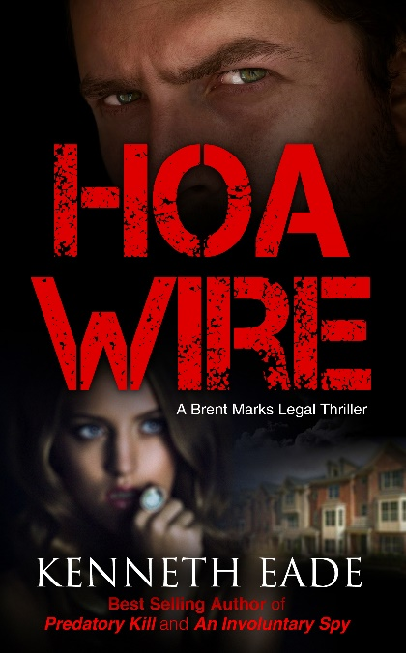

The president of the Orange Grove Homeowners Association is murdered and every resident is a suspect.

Lawyer Brent Marks thinks he is dealing with a routine foreclosure defense until his client is implicated in the crime and calls upon Brent to defend her. To make matters worse, another client's destiny is about to cross their path. Is Brent defending an innocent or guilty client? At the crossroads of morality and ethics, the courtroom drama explodes, while the action outside the courtroom spirals out of control.

Midwest Book Review said, "HOA Wire successfully weaves crime and courtroom to such a degree that the unexpected conclusion comes as both a successful, logical outcome and as a real surprise. With its real insights on HOA processes and neighbor disputes, HOA Wire is a deft exploration of attorney-client ethics on the line, and is crime/courtroom writing at its best."

Reader’s Favorite said, "HOA Wire by Kenneth Eade was a very good book, written by a lawyer. A combination of courtroom drama and crime, it’s full of twists and turns and a very surprising ending. It’s an intriguing story, going in a different direction at every corner."

Top Books Worth Reading said, "Crime, betrayal, thought-provoking questions related to ethics and morality – this novel has everything it needs to become a must-read for any lover of true crime literature.”

I Publisher News said, “HOA Wire is much more than a suspenseful, fast-paced crime novel; it is a courtroom drama that will remind readers of pulp thrillers and will keep them glued to the pages. Eade is brilliant when it comes to creating complicated, intriguing stories that end in mind-blowing surprises, and some have said that his novels will remind readers of John Grisham, proving that Kenneth Eade deserves to be on the same lists with the world’s greatest thriller authors.”

InD’Tale Magazine said, "This is part of series, however totally stands on its own. It’s a great murder mystery"
Says Eade, “I set out to write a traditional murder mystery/courtroom drama, but ended up tackling the very real issue of the overreaching of homeowner’s associations,” said Eade. “Many people may have heard stories about HOAs violating property owners’ rights by suing them for parking their own cars in their driveways, or ridiculous things like that, but the scary part of it all is they can assess huge assessments and legal fees and even foreclose on homeowner’s homes,” he added.
The story was inspired by two real life cases handled by Eade, one of which his client was arrested for contempt of court arising out of a case where she painted her house the wrong color, and the other in which his clients’ home was foreclosed and they were evicted for delinquent assessments and attorneys’ fees. This inspired him to write a story where the president of a local HOA is murdered and, since she is hated by all in the housing development, there are plenty of suspects.

UNREASONABLE FORCE

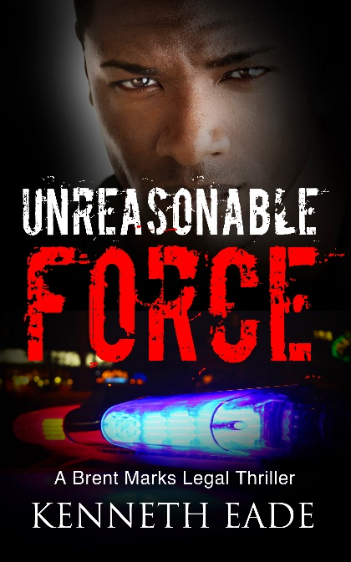

“Injustice anywhere is a threat to justice everywhere.” – Martin Luther King
William Thomas grew up with a distrust of contact with the police. However, he worked hard and made a name for himself as a successful lawyer. After leaving a ball game with friends, Thomas is assaulted by police and one of them is killed. Accused of murder, William calls his colleague, Brent Marks, to defend him. Can Brent convince the jury that the police have crossed the line between keeping order and police brutality? This contemporary novel confronts a contemporary reality of tolerance, prejudice and violence in American society.
InD’Tale Magazine said, "An insightful and thought provoking look into the politics of the criminal justice system."
NY Books Examiner said, “Unreasonable Force is a fast-paced, action-packed legal thriller, but it's also much more than that. It speaks directly to the readers, drawing their attention towards what's happening in reality, around them, each day of their life."
Says Eade of Unreasonable Force, “Police brutality is an issue that has been brought to light by such cases as Michael Brown and Sandra Bland. This is a fictional story, but it strikes at the heart of something which is tearing our country apart. We have become desensitized to violence. We have objectified people and have never been able to escape our racist past. Our police forces are paramilitary forces that are in constant search of an enemy, and we have become too willing to accept war and violence as part of our existence as a country.”

Why Black Lives Have to Matter
Speaking as an attorney and an author who has researched the subject thoroughly for my novel, "Unreasonable Force," I think that the Black Lives Matter movement has done a lot to generate awareness in the last two years about how blacks are treated differently by our society in general, and by the police in particular. However, the roots of police violence go far deeper than just our historic racism. It is an epidemic that has grown to unacceptable proportions because our society has become desensitized to war and violence, and the police have become militarized and identify African Americans as targets.
There has been much controversy discounting the movement by saying that “All Lives Matter.” Of course all lives matter, but all lives can never matter unless we first address the problem of police brutality directed toward people of color. Of course, there are cases of police brutality against people of all races in America, but the overwhelming majority of police violence involves attacks against black people.
This problem of police brutality has been exacerbated by the government and the mainstream
media which follows it. We are a militarized nation. We have been purposely fed information by the military industrial complex which has made us desensitized to violence and war. At home, we accept violence in our streets, using the "us or them” mentality which makes us objectify
our fellow human beings instead of treating them as such. African Americans are the “us,” and the Black Lives Matter movement is important, because society in general, and the police forces of America specifically, are treating black people as the “them.” Too many police officers, upon confronting a black person, immediately assume that suspicious activity may be afoot, and that puts them on a state of alert that can cause unnecessary deadly effects.
There should be no more “boots on the ground” at home. Police violence is out of hand, and the use of bodily force and deadly force are kept in check by nobody, because cops are allowed to make decisions about what level of force to use with virtually no supervision. This can have deadly consequences for an innocent, unarmed person, against whom the officer has no legal right to use such force. It is a problem which must be addressed with education and activism at the local level, and Congressional representatives who represent the military industrial complex must be voted out on the national level. Black Lives Matter can make a difference, but they need the support of all other lives if anything is going to change.

KILLER.COM

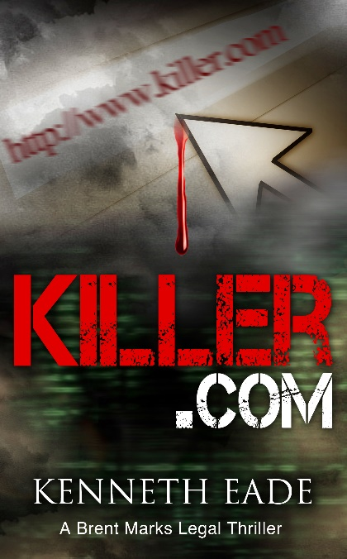

Murder goes high tech
A mob of anonymous cyber stalkers torments lawyer Brent Marks with defamatory posts on the Internet in this latest installment of the legal thriller series. When Marks sues to enjoin their libelous publications, the stalkers hide behind the immunity of the Communications Decency Act. Then a mysterious anonymous killer for hire strikes, and Brent finds himself on the wrong side of the law.
InD’Tale Magazine said, "A suspenseful thriller with a unique plot that will keep readers on the edge of their seats!"
I Publisher News said, "The book is written in a real-time pace where the reader is dropped right into the scene and is placed in the eye to eye level with Brent and the rush of events that occur."

Top Books Worth Reading said, "Eade has established himself not only as a best-selling crime author but also as a seasoned legal professional with three decades of experience. When you read any of his books, you not only walk away with an intense thrill ride, but also an unforgettable lesson in law.

“In my latest novel, I thought it may be interesting to examine the possibility of an Internet bully or cyber mob hiring a hit man anonymously through the Internet. I thought that this would be a unique idea, but, upon delving into the macabre world of the Dark Net, I realized that it was not. Most of the sites where I found for murder-for-hire were probably scams or were set up by law enforcement to catch would-be conspirators, but the concept is definitely not an original one.”

The Devil and the Dark Net

The Internet has outgrown the common law of defamation, and new regulations to protect the Internet, free speech and the freedom to speak anonymously have been abused by cyber-bullies and cyber-stalkers, who have used this new medium to dispense their bullying in a greater distribution among more people. In my latest novel, I thought it may be interesting to examine the possibility of an Internet bully or cyber mob hiring a hit man anonymously through the Internet. I thought that this would be a unique idea, but, upon delving into the macabre world of the Dark Net, I realized that it was not.
The Dark Net is a controversial network, existing on the Internet, which you can only access using a special browser. The TOR browser is the most popular. Once you descend into the “onion layers” of Dark Net (they are called that because each level is like an onion, you are able to send messages anonymously and pay for nefarious services in Bitcoin, which is untraceable. This has made it somewhat of a mess for law enforcement, who often will pose as a drug dealer or killer for hire in order to make an arrest.
However, while the criminals, such as Silk Road founder Ross Ulbricht are busy using the Dark Net to commit their crimes on a larger scale, the normal Internet is home to anonymous cyber bullying, which has taken bullying to higher (and deadlier) heights.
The next victim of the Internet explosion appears to be journalism. Anyone now with an Internet connection and a computer can create a blog that can reach millions of people, thanks to the Google algorithm. In this wild world, anyone can become a publisher, not bound by journalistic ethics that assure that what the public is reading and believing is well researched, responsible content. It is now primarily the Google algorithm which decides what is and is not important, and this algorithm highlights and displays the most popular results, which, in most cases, are the most entertaining and sensational, not the most truthful.
In the days before the Internet, bullies, people jealous of your success, competitors in the workplace, or competing businesses were still out there; but their attacks were short-lived and soon forgotten. The Internet gives them the power to permanently destroy any reputation that is associated with any name that can be “googled,” and the results will outlast your lifetime
Technology has moved faster than the law with regard to the Internet. The Internet gives the defamer the power to destroy a hard-earned reputation with a few clicks of a mouse, with far-reaching effects, to an unlimited audience. The Google algorithm prioritizes the “most popular” searches on the first page of search results, which means that, the more scandalous the gossip is, the better position that gossip will achieve in Google’s results, and the longer it will stay there.
The Internet Age has changed the rules for bullying as well. With the growing phenomenon of cyber-socializing on the Internet, and the fact that school-age children and teenagers have computers, iPads, and cell phones – all with Internet access – bullies can reach a broader audience with their humiliation and hate speech, do it instantaneously, and the defamation assumes a permanent place in cyberspace. This is known as cyber-bullying, and it has reached such epidemic proportions that it has been cited as the cause of many teenage suicides, such as the case of Megan Meier in 2006.
But cyber-bullies do not stop when they leave school. They become cyber-stalkers. The problem with cyber-stalkers is that they have more power when they are cloaked in anonymity, as well as less responsibility. If a cyber-stalker acts anonymously, it is harder to identify him and bring him to justice. Anonymous free speech has been upheld by the U.S. Supreme Court in Talley v. California, 362 U.S. 60 (1960). Of course, that was over 50 years ago, when there was no Internet; but it’s still a good law.
Courts have extended the protection of anonymous speech to the Internet. The U.S. Supreme Court recognized it in the case of McIntyre v. Ohio Elections Commission, 514 U.S. 334, 341-342 (1995). In Doe v. 2The mart.com, Inc., 140 F.Supp 2d 1088, 1093 (WD Wash 2001) the federal district court in Washington stated, "The right to speak anonymously extends to speech via the Internet. Internet anonymity facilitates the rich, diverse, and far ranging exchange of ideas.” In the past ten years, the explosive use of the Internet has radically changed institutions and customs we have had for centuries. It is time for the law to catch up with technology.

AN INVOLUNTARY SPY

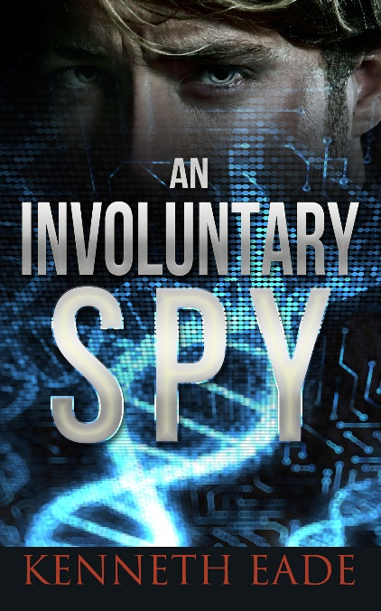

Exposing the truth marked him for murder

Seth Rogan was a bad spy. That’s because he wasn't a spy at all. Just a guy trying to do the right thing. As a biologist for the largest biotech company in the world, he had a great job, and thoroughly enjoyed all the perks. But when asked to do some tests on the company's genetically engineered (GMO) foods, he became entangled in a trail of corruption, fraud and conspiracy that he wanted no part of, but could not escape from. In an espionage story of mystery and suspense so true to life it could almost be from today's newspapers, Seth, having bit the hand who fed him, is on the run from CIA, and the full overreaching strength of the United States government, not as a whistleblower, but as a fugitive, charged with espionage, who finds temporary refuge with an old enemy of the U.S. But his peace is about to be broken as he finds himself in the role of an involuntary spy.

2014 RONE Awards Finalist for best suspense thriller. Used as course material for Environmental Ethics, Values and Justice course at Columbia University.
Midwest Book Review said, "Any who want a more realistic, modern-day James Bond complete with contemporary ethical concerns will find themselves held hostage to the fast action and intrigue in An Involuntary Spy, right up to the satisfyingly-unpredictable conclusion made all the more powerful for its real basis in today's uncertain experiments, compliments of Monsanto, Dow and other genetic manipulators."
San Francisco Book Review said, “Nominated for a 2014 Rone Award in mysteries/thrillers, An Involuntary Spy is absolutely riveting, suspenseful, and an eye-opener to the controversial effects of genetically engineered food.”
Bubblews said, “There's nothing better than spending a lazy afternoon with a cup of hot chocolate and an action-packed thriller that can help you forget about your surroundings and take you to a world of spies, agents, and unlikely heroes. If you plan on spending such an afternoon, then "An Involuntary Spy" is one of the best choices you can make. Adventure, corruption, passion, excitement, and an average guy who never thought his perfectly normal job would get him into so much trouble. What more could you ask for?"
Atlanta Health Examiner said, “It just could be that this book breaks the real life controversy wide open. There are untold mysteries that may not be known for decades. Altering the foods we eat cannot be done without consequences. If natural is best for human health, GMOs are the worst."
“When I wrote this book, I sought to write an action packed political thriller that was not the "same old thing." Instead of Americans going after evil Russians or terrorists who are out to destroy the world, this book is about real things that could really happen in today's political context of government corruption and the revolving door and genetically engineered foods. Although this book is fiction, and you can decide for yourself which side of the GMO controversy to be on, I hope that it makes you question how much control the people have given up of their government. I also hope it gives you an idea of the critical mass our world environment is nearing.”

